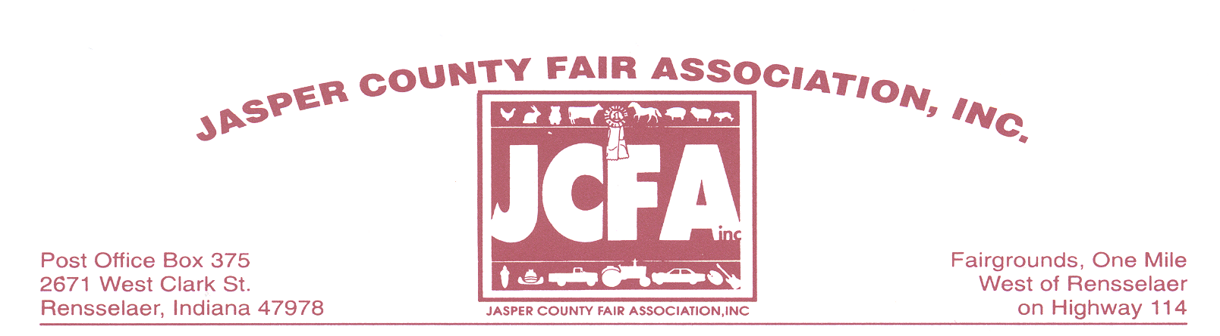
February 5, 2016

Dear Future Exhibitor:

The 2016 Jasper County Fair will be held from July 16th thru July 22nd. After reviewing the information provided in the letter, please complete the enclosed registration form and return by June 24, 2016 to Vickie Bozell. The address is on the registration form.

Space will be assigned on a FIRST COME, FIRST SERVE BASIS. Due to a potential of limited space this year and “prime spots” being requested by all, space will be given to the Individual who has turned in ALL the requirements, which includes the application, deposit, insurance certificate and fees on or before JUNE 24, 2016. We are trying to reward the ones that are very prompt with this and do not have to be tracked down the week of the Fair for the needed items, Thank you for your understanding with this matter.

Electricity is available, the following rates will apply:
15 amp 120volt $ 25.00
20 amp 120 volt $ 30.00
30 amp 120 volt $ 40.00

30 amp 240 volt $ 60.00
40 amp 240 volt $ 85.00
50 amp 240 volt $100.00
60 amp 240 volt $125.00

100 Amp Service will NOT be allowed so please plan accordingly.

Each exhibitor is required to keep the area in and around their exhibit or booth clean at all times. The exhibitor should drop and fasten side tarps of the tent prior to closing their booth for the night. The Jasper County Fair Association, Inc. reserves the right to ask for removal of any and all items which are determined to be detrimental to the fair.

A $50 deposit is required by all exhibitors. We MUST retain a Certificate of Liability Insurance covering your exhibit or booth in our files. Minimum coverage required is $300,000. Receipt of your fees, deposit, application, and Certificate of Insurance is required NO LATER than June 24, 2016. Before you will be allowed to set up at the fair all applications, fees, deposits and certificates of Insurance must be on file with the Jasper County Fair Association. There will be no exceptions!

Camping is available for those who wish to camp on the grounds please contact Homer or Theresa Lakin at 219-866-8413, to reserve you spot and obtain the proper paperwork. The fee to camp per week is $100.00 per week.

.

Exhibitors will set up on: Friday July 15th from 4 pm to 8 pm
Saturday, July 16th from 8 am to 4 pm

Vendor hours are: Saturday July 16th – 4 pm to 9 pm
Sunday, July 17th – 1 pm to 9 pm
Monday-Thursday, July 18th thru July 21nd - 5:30 pm to 9 pm
Friday, July 22nd 5:30 pm to 10 pm
Any exhibitor not in compliance with this time

Schedule will FORFEIT their deposit

Breakdown time: Not before Friday, July 22nd beginning at 10 pm
Your deposit will be returned to you at this time
and NO EARLIER! If the exhibitor is gone prior to
that time the deposit will be FORFEITED.

Food permits need to be applied for by July 5, 2016 (this also applies if you operate a restaurant in Jasper County and have a health permit for your business) from the Jasper County Health Department. The Health Department will not issue permits after July 5, 2016. There are NO PETS allowed on the grounds! Food vendors are to have their prices posted on at least a 2x2 board for the customers to see at all times.

The State Fire Marshall’s Office will have a representative on the grounds. Please comply with all state fire codes.

We look forward to seeing you at the 2016 Jasper County Fair! If we can be of any further assistance, please do not hesitate to call.

Sincerely,

Tom Moore
Tom Moore, President
Jasper County Fair Association, Inc.

For additional information contact:

Vickie Bozell 219-866-8991
2099 W Division Rd 219-866-9069
Rensselaer, IN 47978
jaspercountyfair.weebly.com or vickie.bozell@co.jasper.in.us

Or

Rich Moore 219-405-7127

For information regarding Food Permits ONLY contact:
Jasper County Health Department
105 W. Kellner Blvd.
Rensselaer, IN 47978
219-866-4917

EXHIBITOR APPLICATION

Food Trailers: $20.00 per frontal footage
Commercial Trailers: $20.00 per frontal footage
Food Stand: $825.00
South Food Building: $1200.00
$300.00 for Electricity; $250.00 Damage Deposit

Outside Area $20.00 per frontal footage
12 x 12 Tent Only $220.00
20 x 30 Tent Only $410.00
(Please Note: The above tent costs does not include the frontal footage, that is an additional charge)
Example: 20ft frontage with a 20 x 30 tent would cost: $400 for frontage and $410 for tent rental:
Total Cost would be: $810.00 plus electric, water (if needed) and deposit.

PLEASE MAKE CHECK PAYABLE TO: JASPER COUNTY FAIR ASSOCIATION, INC.

Please note that as of January 1, 2010, Jasper Co. Fair Association has a new check acceptance policy:
All checks must have the signers Driver’s License Number on the Check or it will not be accepted as payment.
All Returned checks will be assessed a $27.50 returned check Fee
No Checks will be accepted after June 10, 2016 (cashier’s check or cash only after this date)

RETURN YOUR CHECK AND THE BOTTOM PORTION OF THIS FORM TO:
**REQUIRED
Vickie Bozell
2099 W Division Rd
Rensselaer, IN 47978

Name: ____________________________________________________Phone:_____________________

Address: ________________________________________City/State/Zip__________________________

**DOB_________________________ DL#_______________________ Check #_______________

e-mail address:________________________________________________________________________

Name of Business______________________________________________________________________

**Description of Exhibit___________________________________________________________________

Please list the size of the food trailer that you will be bringing:___________________________________

Food Trailer /Commercial Trailer $___________
Outside Area $20.00 per frontal footage $___________
12 x 12 Tent Only $___________
20 x 30 Tent Only $___________
Food Stand $___________
South Food Building $___________
Electricity – see page 1 $___________
Additional electrical amp $___________
Water $25.00 $___________
Security Deposit @ $50.00 $___________

TOTAL $___________

I AGREE THAT I WILL NOT HOLD THE JASPER COUNTY FAIR ASSOCIATION, INC. RESPONSIBLE FOR LOSS, DAMAGE OR INJURY OF MY PROPERTY DURING THE COURSE OF THE JASPER COUNTY FAIR. I CERTIFY THAT MY DEPOSIT AND CERTIFICATE OF INSURANCE ARE ENCLOSED WITH THIS APPLICATION.

Signature ____________________________________________________Date__________________

