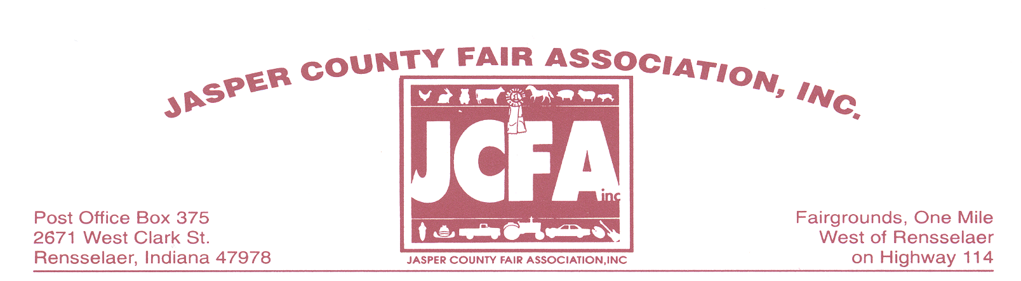
February 10, 2020

Dear Future Exhibitor: **NOTICE---CHANGE IN FAIR DATES**

The 2020 Jasper County Fair will be held from July 25th thru Aug 1st. After reviewing the information provided in the letter, please complete the enclosed registration form and return by June 26th 2020 to Vickie Bozell. The address is on the registration form.

Space will be assigned on a FIRST COME, FIRST SERVE BASIS. Due to a potential of limited space this year and “prime spots” being requested by all, space will be given to the Individual who has turned in ALL the requirements, which includes the application, deposit, insurance certificate and fees on or before JUNE 26, 2020. We are trying to reward the ones that are very prompt with this and do not have to be tracked down the week of the Fair for the needed items, Thank you for your understanding with this matter.
There will be NO refunds after June 26th, 2020.

Electricity is available, the following rates will apply:
15 amp 120volt $ 25.00
20 amp 120 volt $ 30.00
30 amp 120 volt $ 40.00

30 amp 240 volt $ 75.00
40 amp 240 volt $105.00
50 amp 240 volt $125.00
60 amp 240 volt $155.00

100 Amp Service is limited so please plan accordingly.

Each exhibitor is required to keep the area in and around their exhibit or booth clean at all times. The exhibitor should drop and fasten side tarps of the tent prior to closing their booth for the night. The Jasper County Fair Association, Inc. reserves the right to ask for removal of any and all items which are determined to be detrimental to the fair.

A $50 deposit is required by all exhibitors. We MUST retain a Certificate of Liability Insurance covering your exhibit or booth in our files. Minimum coverage required is $300,000. Receipt of your fees, deposit, application, and Certificate of Insurance is required NO LATER than June 26, 2020. Before you will be allowed to set up at the fair all applications, fees, deposits and certificates of Insurance must be on file with the Jasper County Fair Association. There will be no exceptions!

Camping is available for those who wish to camp on the grounds please contact Homer or Theresa Lakin at 219-866-8413, to reserve your spot and obtain the proper paperwork. The fee to camp per week is $110.00 per week.

.

Exhibitors will set up on: Friday July 24th from 4 pm to 8 pm
Saturday, July 25th from 8 am to 4 pm

Vendor hours are: Saturday July 25th – 4 pm to 9 pm
Sunday, July 26th – 1 pm to 9 pm
Monday-Friday, July 27th thru Aug. 1st - 5:30 pm to 9 pm
Saturday, Aug. 1 5:30 pm to 10 pm (Fireworks @ 9:00)
Any exhibitor not in compliance with this time

Schedule will FORFEIT their deposit

Breakdown time: Not before Saturday, Aug. 1st beginning at 10 pm
Your deposit will be returned to you at this time
and NO EARLIER! If the exhibitor is gone prior to
that time the deposit will be FORFEITED.

Food permits need to be applied for by July 10, 2020 (this also applies if you operate a restaurant in Jasper County and have a health permit for your business) from the Jasper County Health Department. The Health Department will not issue permits after July 10, 2020. There are NO PETS allowed on the grounds! Food vendors are to have their prices posted on at least a 2’x 2’ board for the customers to see at all times.

The State Fire Marshall’s Office will have a representative on the grounds. Please comply with all state fire codes.

We look forward to seeing you at the 2019 Jasper County Fair! If we can be of any further assistance, please do not hesitate to call.

Sincerely,

Vickie Bozell
Vickie Bozell, President
Jasper County Fair Association, Inc.

For additional information contact:

Vickie Bozell
2099 W Division Rd 219-866-9069
Rensselaer, IN 47978
jaspercountyfair.weebly.com or rvbozell@outlook.com

Or

Rich Moore 219-405-7127

For information regarding Food Permits ONLY contact:
Jasper County Health Department
105 W. Kellner Blvd.
Rensselaer, IN 47978
219-866-4917

EXHIBITOR APPLICATION

Food Trailers: $25.00 per frontal footage
Commercial Trailers: $25.00 per frontal footage
Food Church Stand: $825.00--RENTED
South Food Building: $1200.00-$300.00 for Electricity; $250.00 Damage Deposit--RENTED
Outside Area $25.00 per frontal footage
10 x 10 Tent Only $250.00—in addition to your frontal footage
20 x 30 Tent Only $510.00---in addition to your frontal footage
(Please Note: The above tent costs does not include the frontal footage, that is an additional charge)
Example: 20ft frontage with a 20 x 30 tent would cost: $510 for frontage and $410 for tent rental:
Total Cost would be: $920.00 plus electric, water (if needed) and deposit.

PLEASE MAKE CHECK PAYABLE TO: JASPER COUNTY FAIR ASSOCIATION, INC.

Please note that as of January 1, 2010, Jasper Co. Fair Association has a new check acceptance policy:
All checks must have the signers Driver’s License Number on the Check or it will not be accepted as payment.
All Returned checks will be assessed a $27.50 returned check Fee
No Checks will be accepted after June 19, 2020 (cashier’s check or cash only after this date)
No refunds will be given after June 26, 2020, you $50.00 deposit will be forfeited.

RETURN YOUR CHECK AND THIS FORM TO: Vickie Bozell, 2099 W Division Rd, Rensselaer, IN 47978
**REQUIRED

Name: ____________________________________________________Phone:_____________________

Address: ________________________________________City/State/Zip__________________________

**DOB_________________________ DL#_______________________ Check #_______________

e-mail address:_______________________________________________________________________

Name of Business______________________________________________________________________

**Description of Exhibit or provide menu____________________________________________________
____________________________________________________________________________________
Please list the size of the food trailer that you will be bringing AND share if you are serving out of the end or the side of your trailer:___________________________________________________________________________________
If you are a food vender and would like to serve our Queen and her court a meal please check here_____ Thank You.

Food Trailer /Commercial Trailer/Tent
Outside Area $25.00 per frontal footage $___________
10 x 10 Tent Only=$250.00 $___________
20 x 30 Tent Only=$510 .00 $___________
Food church Stand----RENTED $___________
South Food Building---RENTED $___________
Electricity – see page 1 $___________
Additional electrical amp $___________
Water $30.00 $___________
*Security Deposit @ $50.00 $___________

TOTAL $___________

I AGREE THAT I WILL NOT HOLD THE JASPER COUNTY FAIR ASSOCIATION, INC. RESPONSIBLE FOR LOSS, DAMAGE OR INJURY OF MY PROPERTY DURING THE COURSE OF THE JASPER COUNTY FAIR. I CERTIFY THAT MY DEPOSIT AND CERTIFICATE OF INSURANCE ARE ENCLOSED WITH THIS APPLICATION.

Signature ____________________________________________________Date__________________

